**Q: How do I schedule the exam for AZ-900 from Microsoft portal?**

A: Follow the instructions mentioned below:

**Step 1:** Open the following URL:  
[**https://docs.microsoft.com/en-us/learn/certifications/exams/az-900**](https://docs.microsoft.com/en-us/learn/certifications/exams/az-900)

**Step 2:** Change the country to India

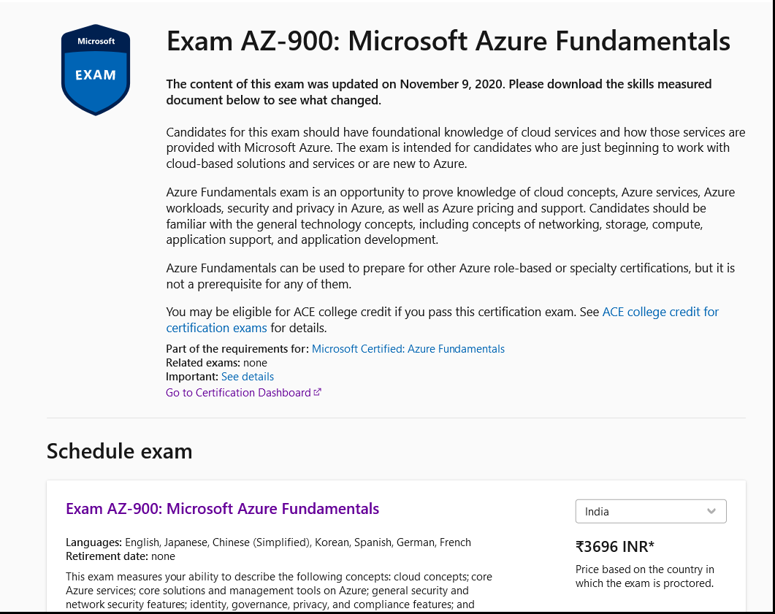

**Step 3:** Select Schedule with Pearson VUE

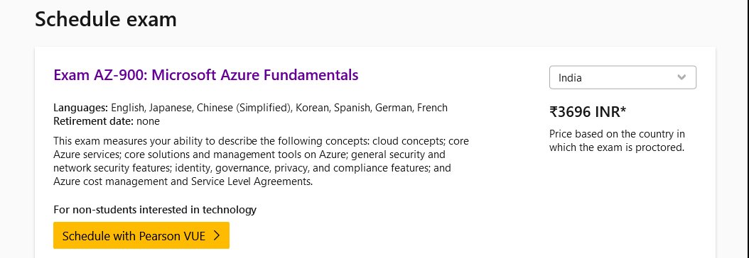

**Step 4:** Provide your personal email id to login

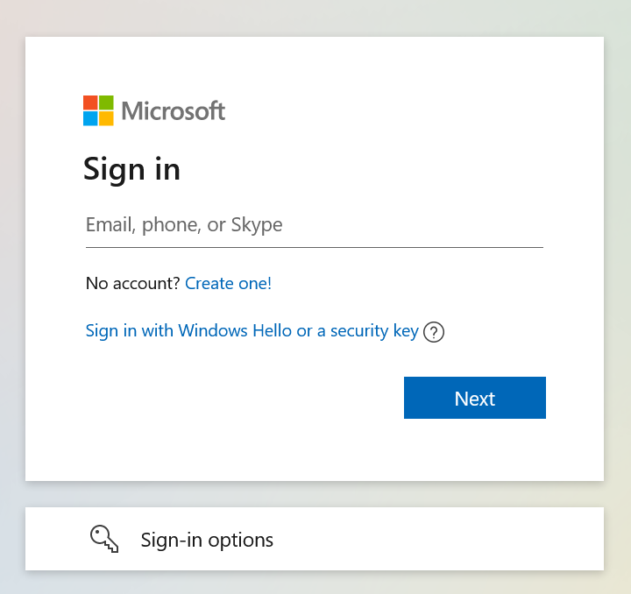

**Step 5:** Complete your profile and click on continue

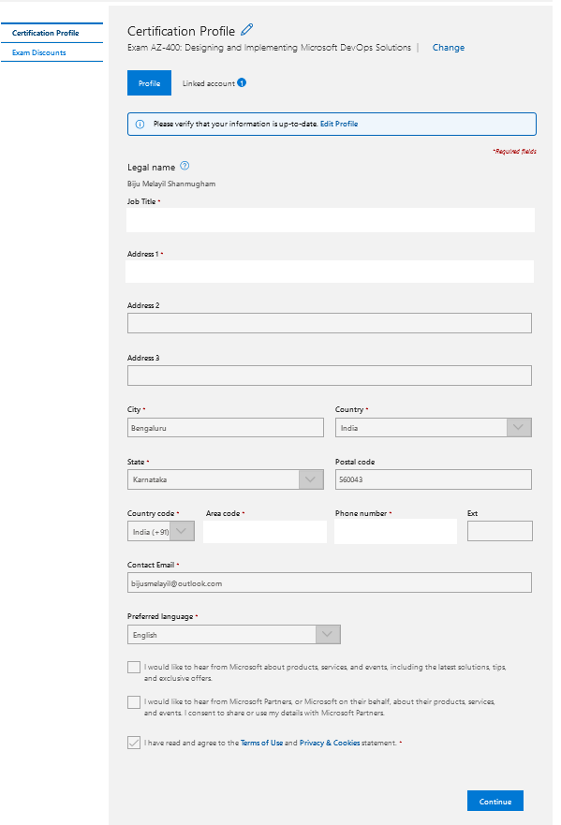

**Step 6:** Enter your email id and click on check eligibility.

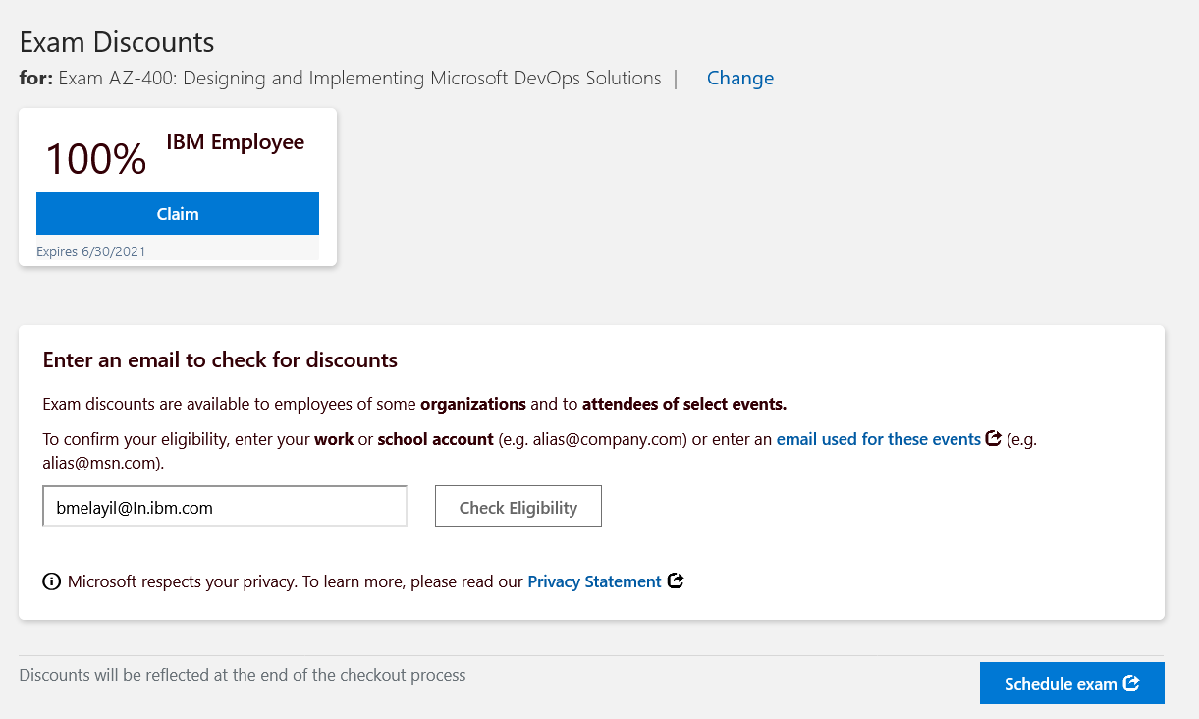

**Step 7:** Click on Agree button and continue

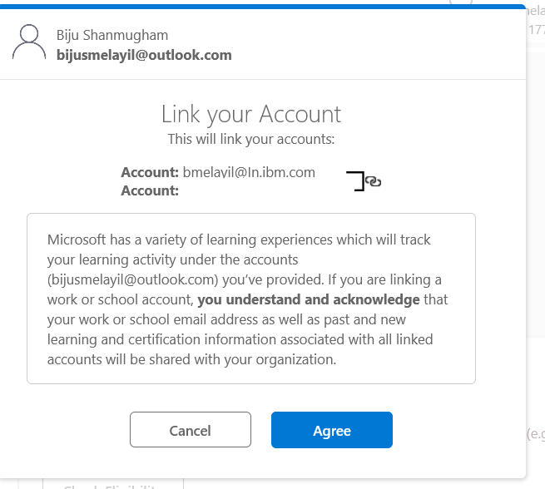

**Step 8:**  Use your IBM email id and sign in.

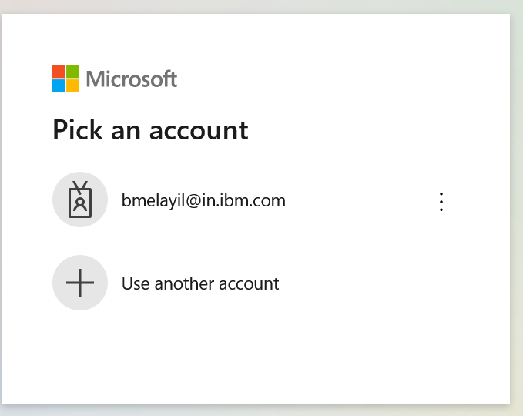

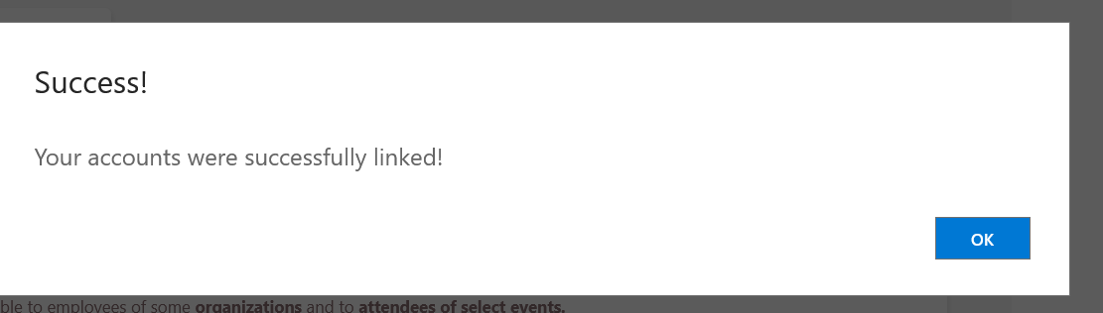

**Step 9:** Click on the claim button

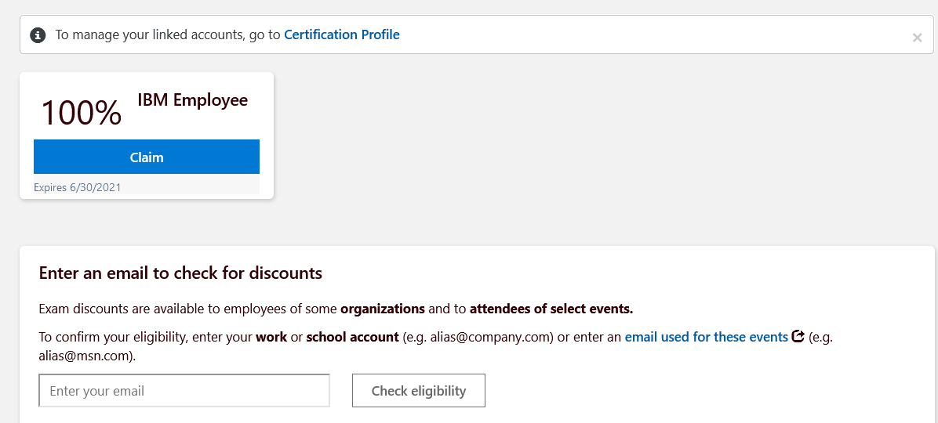

It will show as claimed.

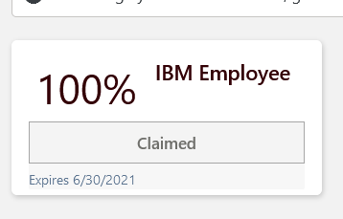

**Step 10:** Click on the schedule button

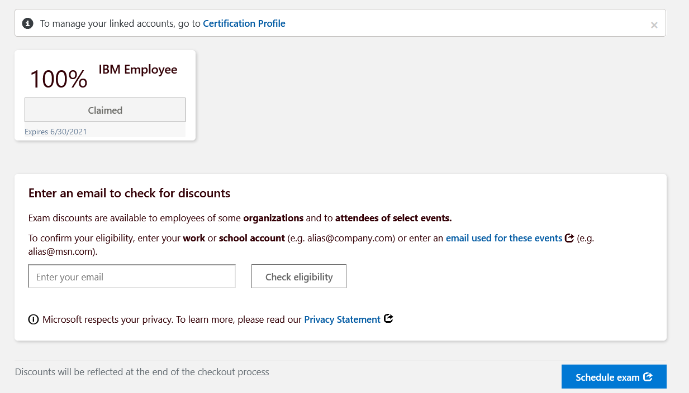

**Step 11:** Select on I’m not a robot and click submit.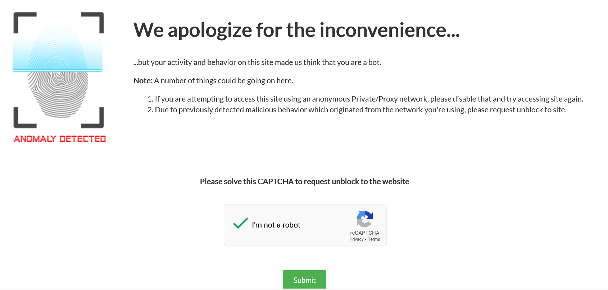

**Step 12:** Select your Exam center, you can choose your center or house as per your convienance and select next.

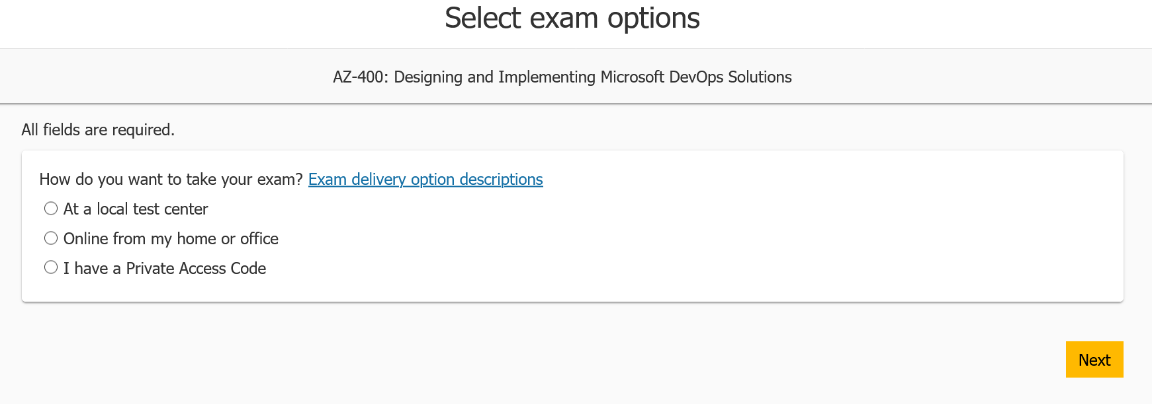

**Step 13:** Select the language to continue.

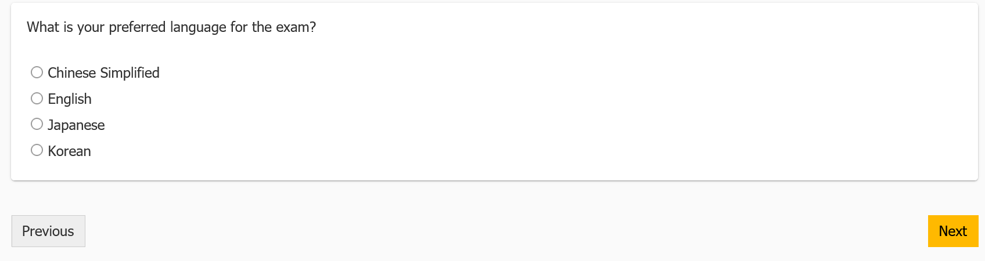

**Step 14**: Select the location and click next

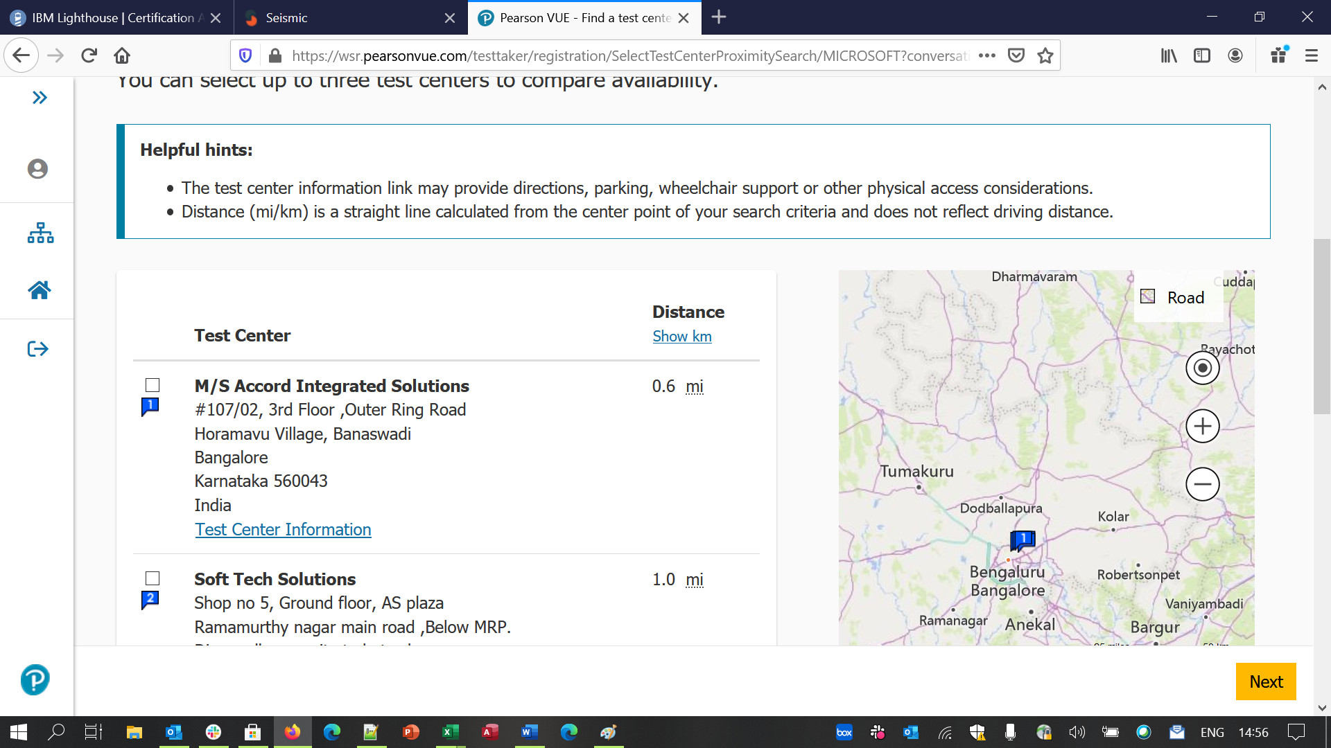

**Step 15**: Select the available date and click next. Available date will be highlighted, and others will be disabled

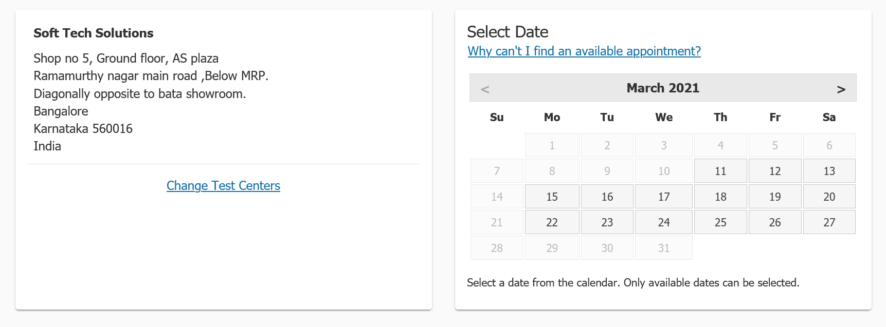

**Step 16:** Select the available slot for exam

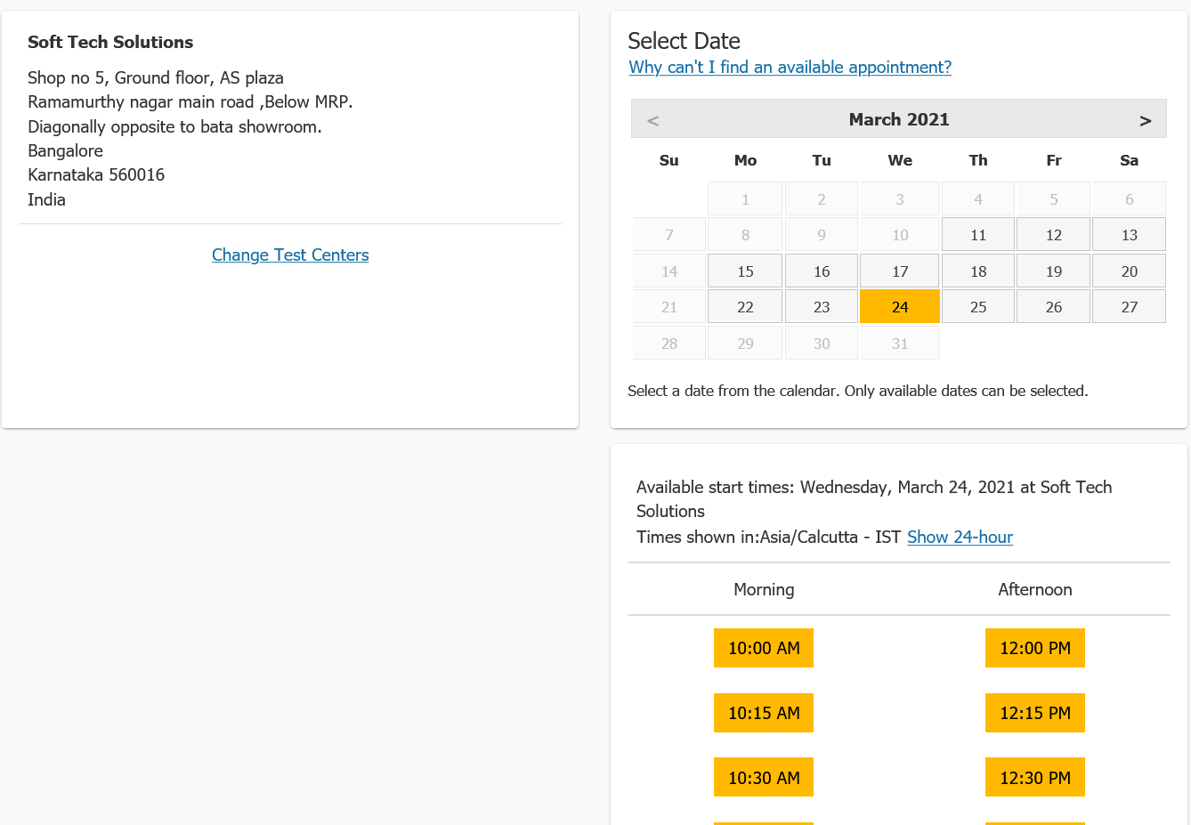

**Step 17:** validate information and click on proceed to check out. Check whether Estimated Total Due is 0:00

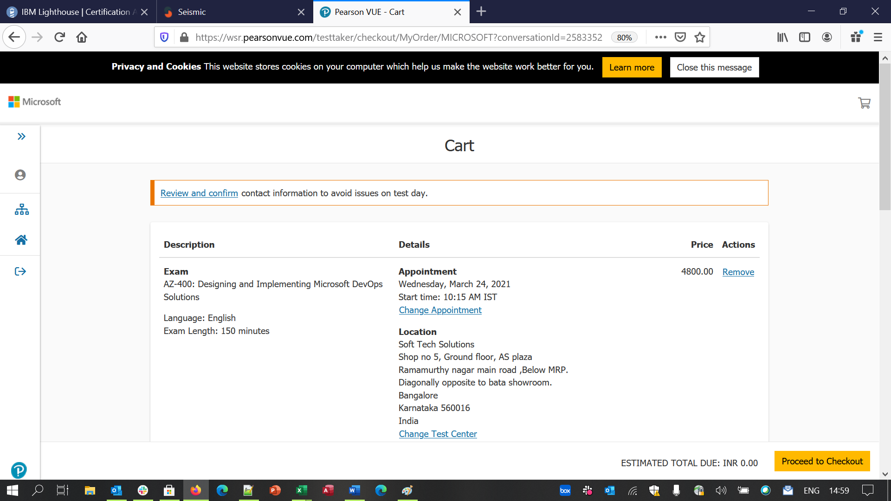

**Step 18:** Complete the process and you will get the confirmation mail in your personal email id.